

YEAR: 9
SUBJECT: SCIENCE

TEST: Matter
TIME: 40 mins
QUESTIONS: Part A: Multiple Choice Questions (10 marks)
Part B: Short Answer Questions (18 marks)
Part C: Extended Response (5 marks)

TOTAL MARKS: 33 marks

DO NOT WRITE ON OR MARK THIS PAPER

SECTION ONE: Multiple Choice Questions (1mark each)
Answer this section on the separate multiple – choice answer sheet

- Which of the following statements about atoms is true?
- Neutrons and protons are found in the nucleus with the electrons
- The number of neutrons found in the nucleus of an atom is always the same
- Protons circle the nucleus all the time
- An atom is mostly empty space

- The nucleus of an atom is made up of
- electrons and protons
- protons and neutrons
- neutrons and electrons
- neutrons

- How many valence electrons does a carbon atom have?

- 6
- 1
- 2
- 4

- The atomic symbol for a gold atom is 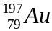. Clarify what this tells you about the gold atom.

- It contains 118 protons.
- It contains a total of 197 protons, neutrons and electrons.
- It contains 118 neutrons.
- It contains 197 electrons.

- What is the electronic configuration of a chlorine atom? Hint: Chlorine has an atomic number of 17

- 2,2,2,2,2,2,2,2,1
- 2,8,7
- 8, 8, 1
- 2,10,5

- Aluminium-28 decays according to the following equation:
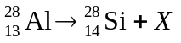
Identify the particle X.
- neutron
- alpha particle (helium nucleus)
- beta particle (electron)
- proton

- A radionuclide is:

- a radioactive isotope.
- a charged atom
- an element that emits beta radiation.
- an atom with the same number of protons but a different number of neutrons.

- The mass number of an atom is the number of

- neutrons in its nucleus.
- electrons in the nucleus.
- protons in the nucleus.
- protons plus neutrons in the nucleus.

- The number of electrons in each shell of an atom is known as its
- electron configuration.
- electron shells.
- atomic symbol.
- mass number.

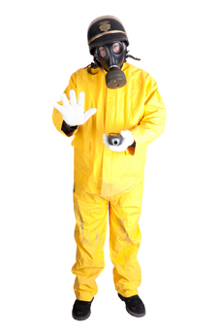
- Scientists use the process of decay in radioactive isotopes called to determine the of organisms.

- aging; carbon
- radioactive aging; carbon
- dating; age
- carbon dating; age


SEMESTER ONE 2017
Chemistry Test:
ANSWER BOOKLET
NAME:
FORM: DATE:

Multiple Choice Short Answer Extended Response Total

/10

/18

/33

/5

SECTION ONE: Multiple choice answers
Cross (X) through the correct answer.

1 | a | b | c | d
2 | a | b | c | d
3 | a | b | c | d
4 | a | b | c | d
5 | a | b | c | d
6 | a | b | c | d
7 | a | b | c | d
8 | a | b | c | d
9 | a | b | c | d
10 | a | b | c | d

SECTION TWO: Short Answer (18 marks)
Answer the questions in the spaces provided.

Question 11

Identify the number of protons, neutrons and electrons in the atoms of tin: (1 mark)

- protons:
- neutrons:
- electrons:

Question 12

Describe how a stable atom changes if you change the number of: (3 marks)
- electrons

- neutrons

- protons

Question 13
Construct electron shell diagrams and write the electron configurations for the following atoms. (4 marks)

a. Oxygen
Electron shell diagram:

Electron configuration:

b. Lithium
Electron shell diagram:

Electron configuration:

Question 14
Carbon has different isotopes, as shown in the diagram below.
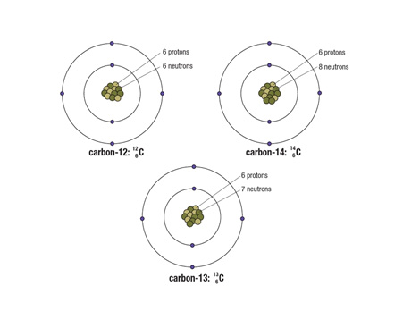
Describe the similarities and differences between these shown. (3 marks)

Question 15
Compare and contrast alpha, beta and gamma decay of radionuclides. (3 marks)

TYPE OF DECAY | COMPARE AND CONTRAST
ALPHA
BETA
GAMMA

Question 16
The atoms below are written using the letters V to Z instead of their correct chemical symbols.
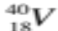 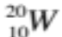 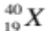 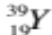 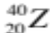 (4 marks)
- Which two atoms have the same number of neutrons?
______________________________________________________________________________
- Which atom has the smallest mass number?
______________________________________________________________________________
c) Which two atoms belong to the same element?
______________________________________________________________________________
- Which atom has the electron configuration 2, 8?
_____________________________________________________________________________
SECTION THREE: Extended Response (5 marks)
Select ONE of the following questions and write the question number in the box below. Answer the question in the space provided.
- Before oxygen can form a molecule it becomes an oxide ion with a charge of –2. Explain what has happened to the atom to form this charge.

Identify if oxide is an anion or a cation.

OR
- Explain why radiation is dangerous for living cells but can be applied to treat people with some forms of cancer.

Question Number:

__________________________
END OF TEST Please check your work!

